**ASSIGNMENT 2 FRONT SHEET**

|  |  |  |  |
| --- | --- | --- | --- |
| **Qualification** | **BTEC Level 5 HND Diploma in Computing** | | |
| **Unit number and title** | Unit 30: Application Development | | |
| **Submission date** |  | **Date Received 1st submission** |  |
| **Re-submission Date** |  | **Date Received 2nd submission** |  |
| **Student Name** | Than Thi Bich Hang | **Student ID** | BH00196 |
| **Class** | IT0501 | **Assessor name** | Nguyen Thanh Trieu |
| **Student declaration**  I certify that the assignment submission is entirely my own work and I fully understand the consequences of plagiarism. I understand that making a false declaration is a form of malpractice. | | | |
|  |  | **Student’s signature** | Than Thi Bich Hang |

**Grading grid**

|  |  |  |  |  |  |  |  |
| --- | --- | --- | --- | --- | --- | --- | --- |
| P4 | P5 | P6 | M3 | M4 | M5 | D2 | D3 |
|  |  |  |  |  |  |  |  |

|  |  |  |
| --- | --- | --- |
| **❒ Summative Feedback: ❒ Resubmission Feedback:** | | |
| **Grade:** | **Assessor Signature:** | **Date:** |
| **Lecturer Signature:** | | |

1. **INTRODUCTION**
2. **CONTENTS**

## **P4 Create a formal questionnaire that effectively reviews your business application, problem definition statement, proposed solution and development strategy. Use this questionnaire as part of a peer-review and document any feedback given**

1. Formal questionnaire

To let everyone know whether the website is working well or not, I created this survey. Let everyone evaluate the website for any errors that need to be fixed. Here are the questions I researched to come up with the questions below:

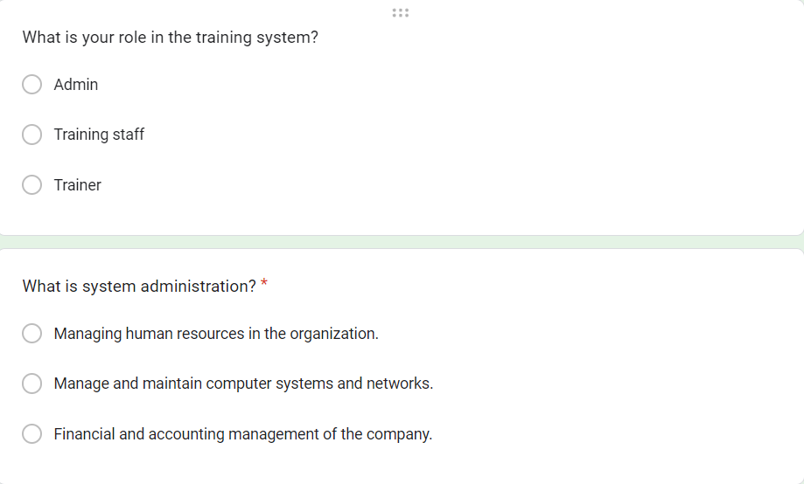

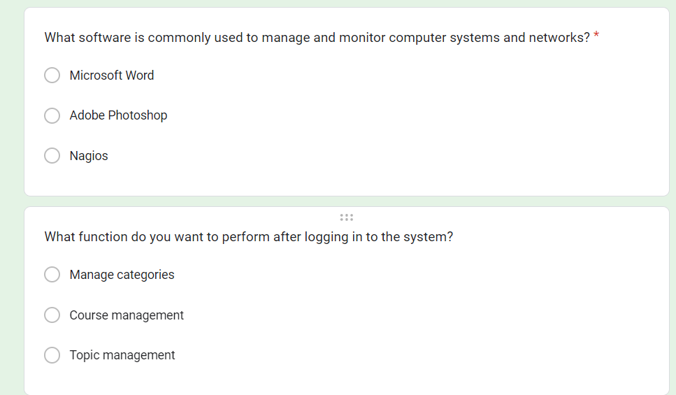

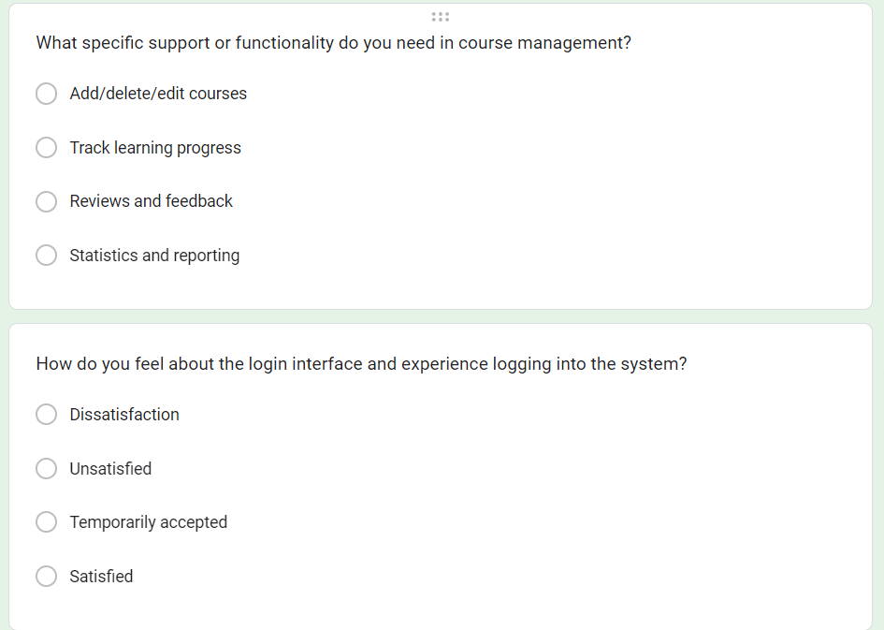

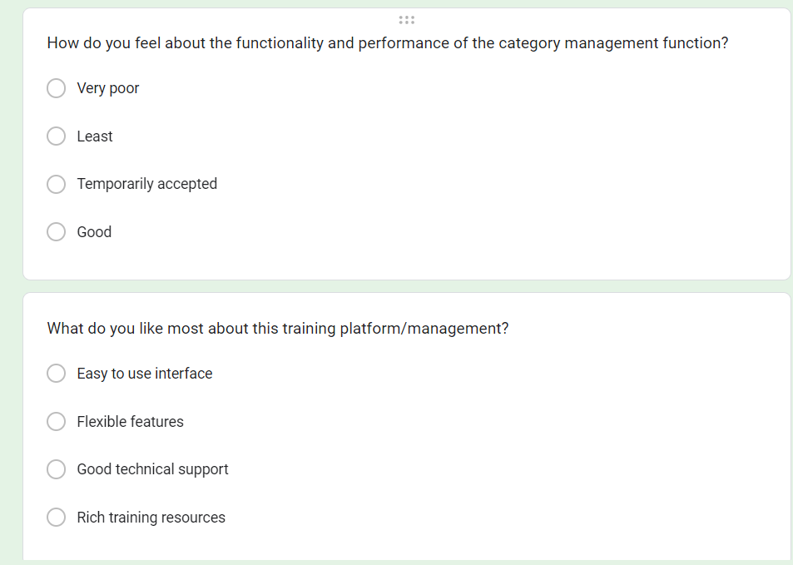

1. The result of survey
   1. Age group

As you can see, people participating in this survey are aged 17 - 25 years old (83.3%), aged 26 - 30 years old (16.7%).

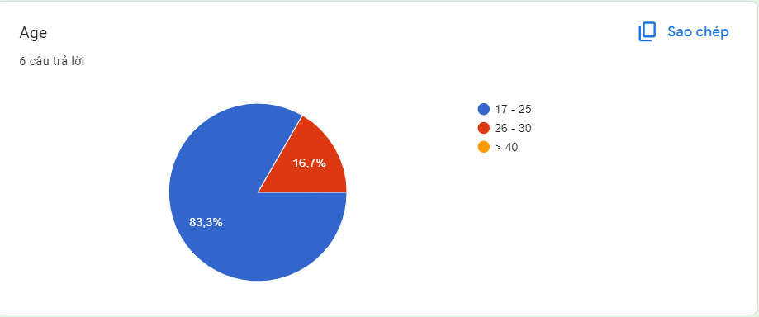

* 1. Role

1. Feedback

## **P5 Develop a functional business application based on a specified business problem**

1. **Requirement**

In ASM1, I learned about diagrams, application tools, languages, developed ideas, and wrote reports. Then in ASM 2, I started implementing the project.

This is the system used by the human resources department. We have three roles in this system, admin, training officer and coach. A brief description of those roles is as follows.

* Role of administrator
* It is possible to log in to the system through the first page of the application.
* Can create/edit/delete new user accounts for instructors/training staff
* and assign/change (if existing user) username and password.
* Role of training staff
* Registered training staff, given a username and login password by the administrator, can create a student account by entering details such as student name, student account, age, date birth, education level, main programming language, Toeic score, detailed experience, department, location, etc.
* After successfully entering all student information, the student information will be saved in the database. The training staff was given a list of students for him to view and search. From the student list, he can also search by student account, programming language, Toeic score...
* You can update and delete trainee accounts.
* Can manage course categories such as searching, adding, updating and deleting course categories. The course catalog includes information such as the course catalog name and description.
* Can manage courses such as searching, adding, updating, deleting courses. Course includes course name and description.
* Topics such as topic name and topic description can be added to a course, courses to a category.
* Can manage lecturer profile such as adding, updating and deleting information: Lecturer name, External or internal type, place of work, phone and email address.
* Instructors can be assigned to a topic.
* Students can be assigned to a course.
* Role of the coach
* In the same system, lecturers who have been registered by admin can log in and update their profile such as Lecturer name, External or internal type, educational level, place of work, phone and email address.

1. **Deployment steps**
2. **Code**
3. **Result**

Below is the project code for Developing an internal training management system for the company



**Login:** Enter the username and password registered in the database

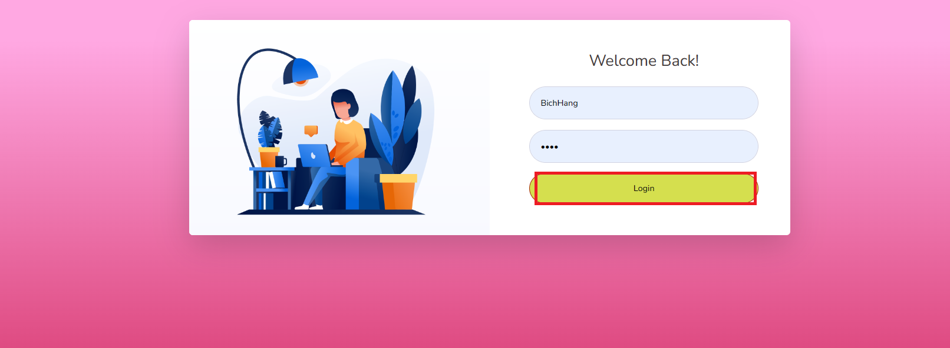

**Login successful**: Login successful: when clicking the "Login" button, the login operation is successful and you can access the home page.

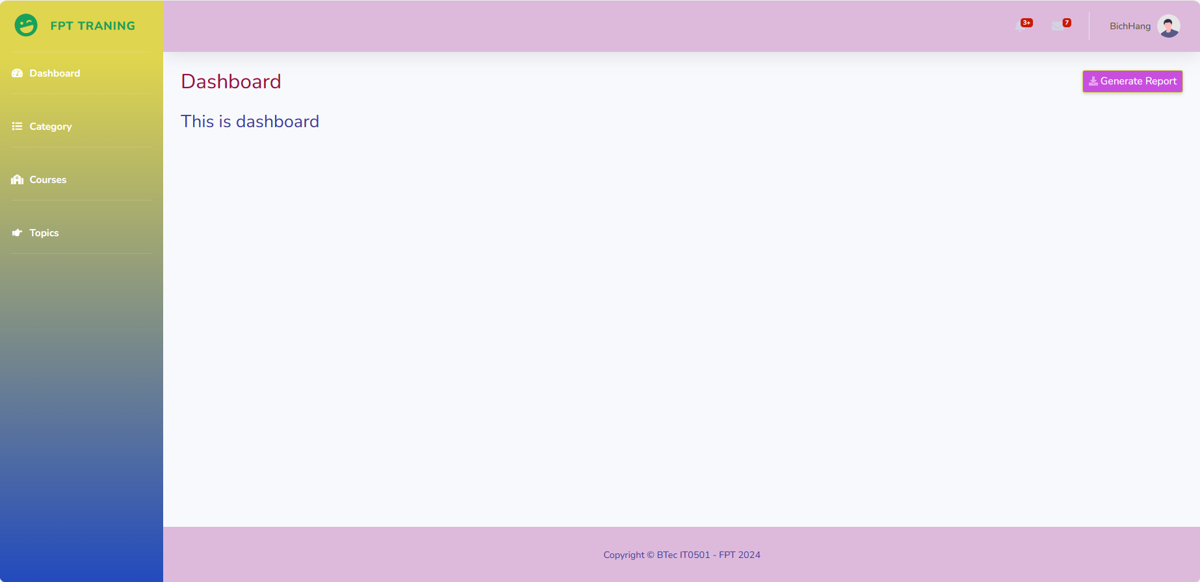

**Category**

When you click on "Category", it will display a category for you to add, edit, delete and display the newly added products.

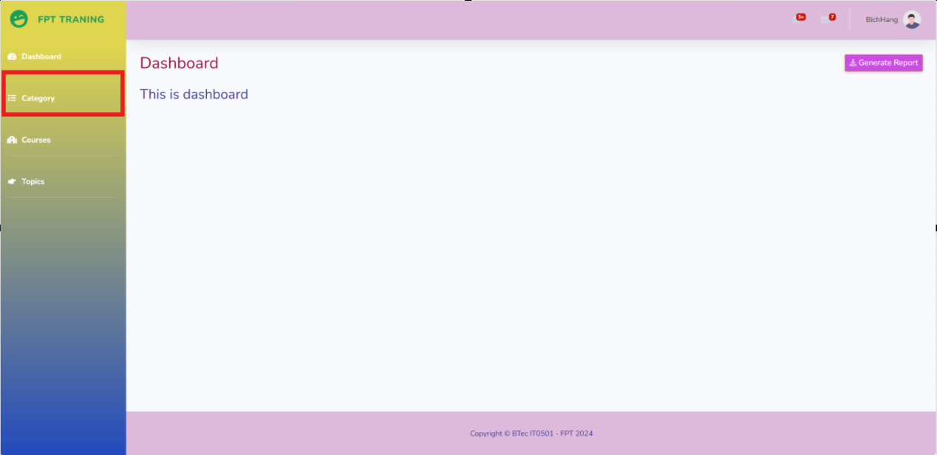

This is the category "Category" displayed

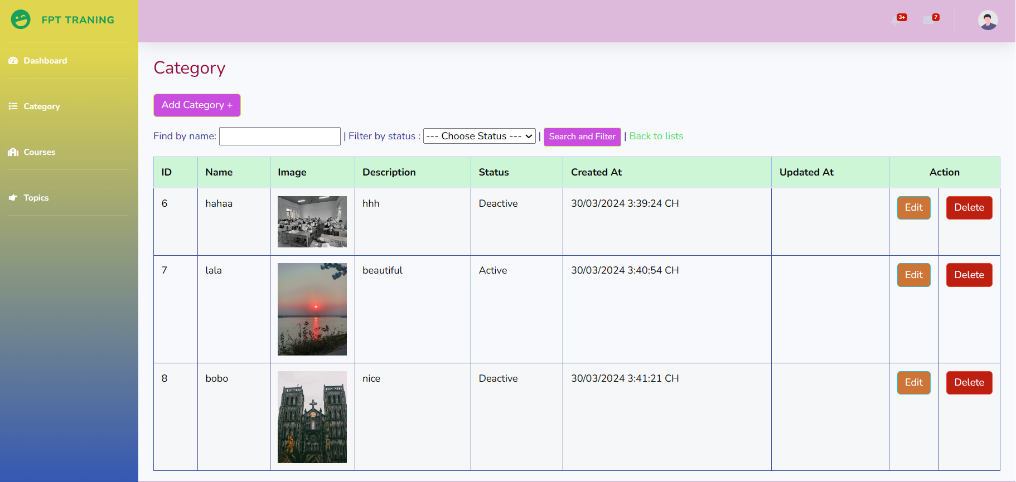

**Add Category**: Enable the addition of a new category

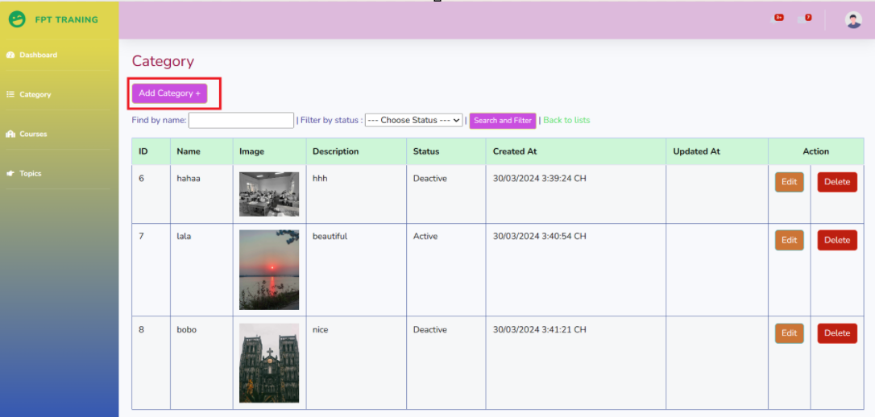

Add the information you need to fill in "Category" and press the "Save" button

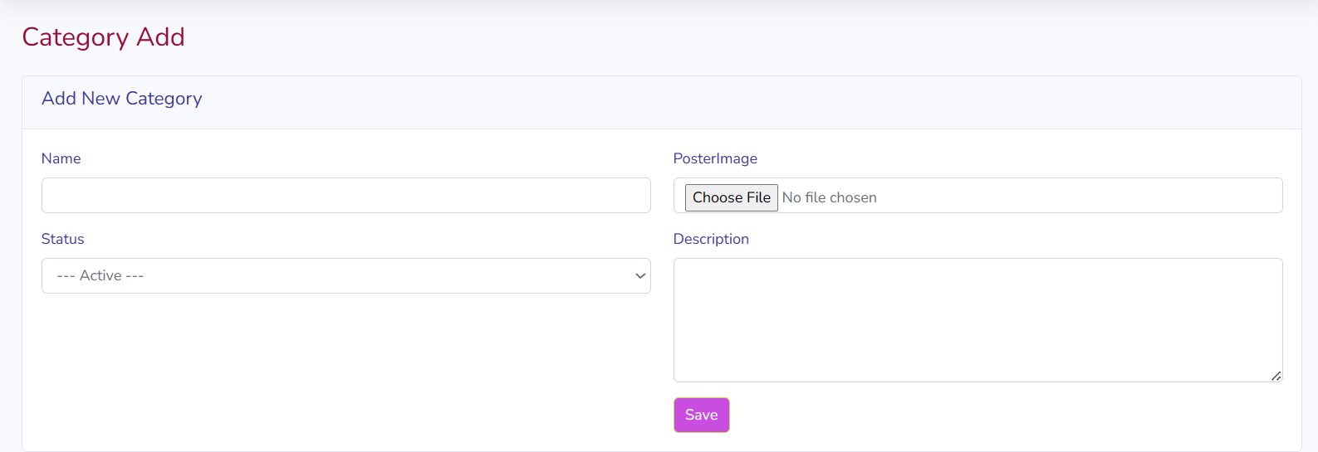

More information press the "Save" button

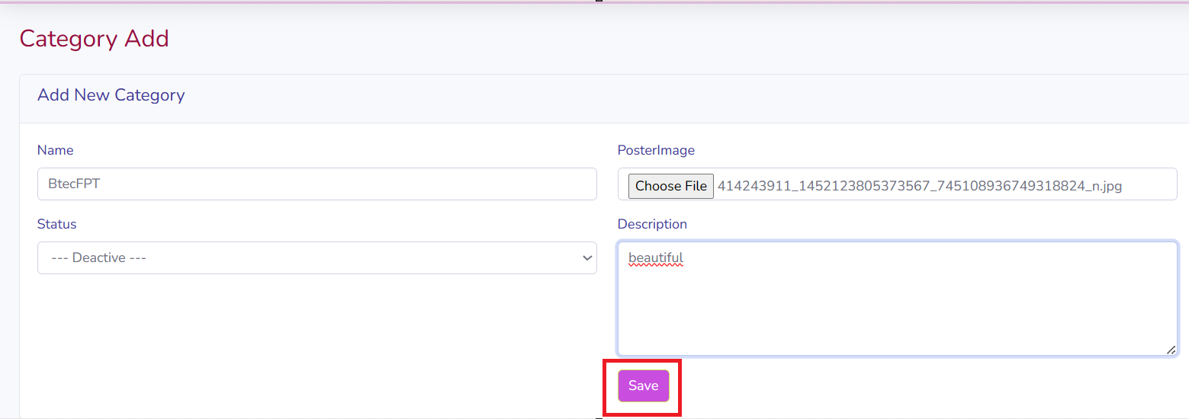

**Add category successful**: upon clicking " Add category ", save operation is successful

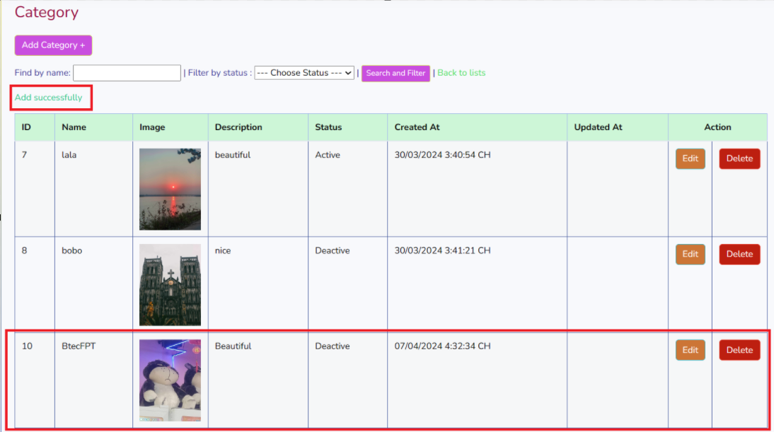

**Edit:** allow modifications to the selected categoryId

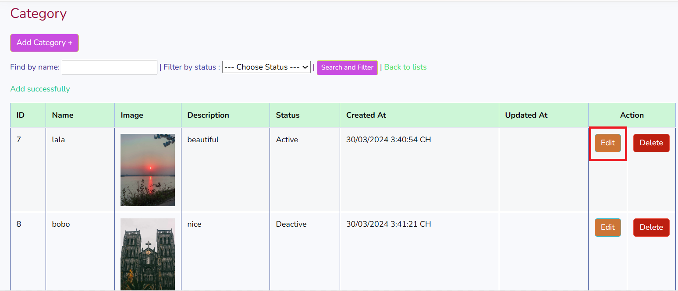

**Edit category successful**: when clicking the " Update Category" button, the category update is successful

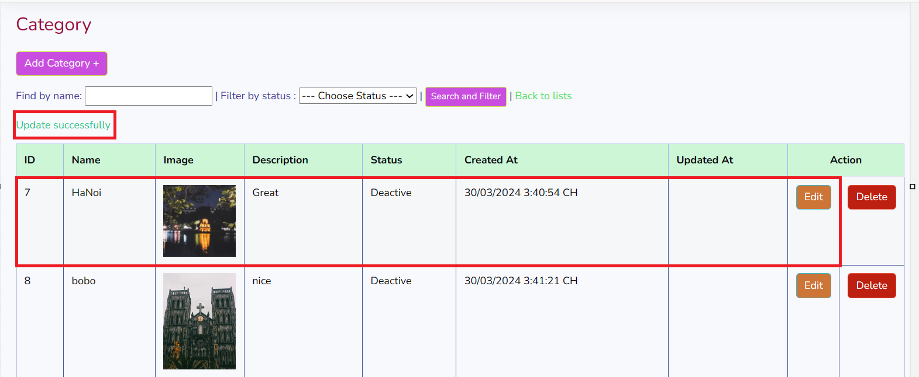

**Delete:** Provide the capability to remove the selected CategoryID.

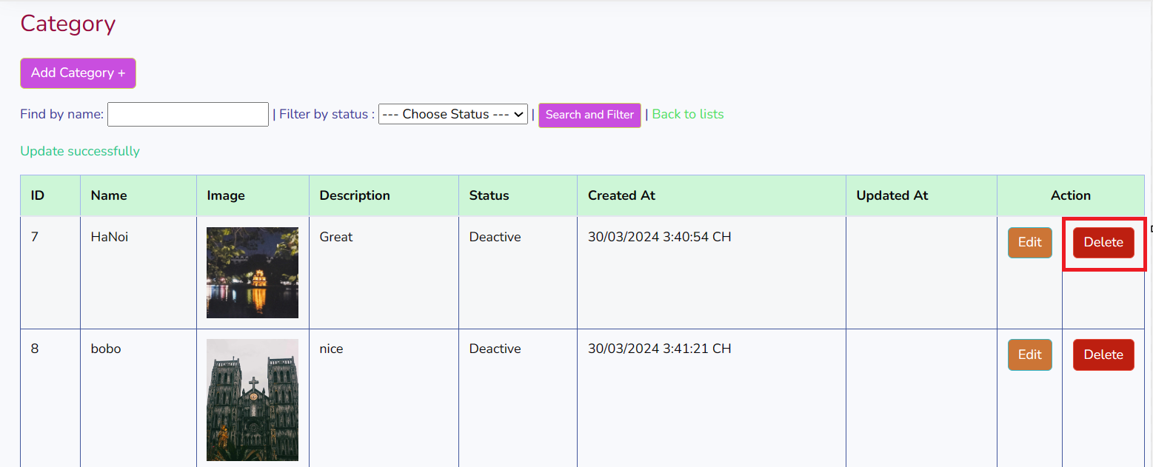

**Delete category successful:** when clicking the" delete category" button, the category deletion is successful.

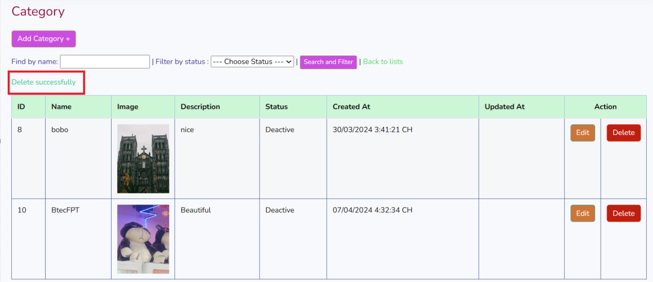

When there are too many categories to search, click "find by name", select "Filter by status" and then press "Search and Filter" to display the content and images of the Category you are searching for.

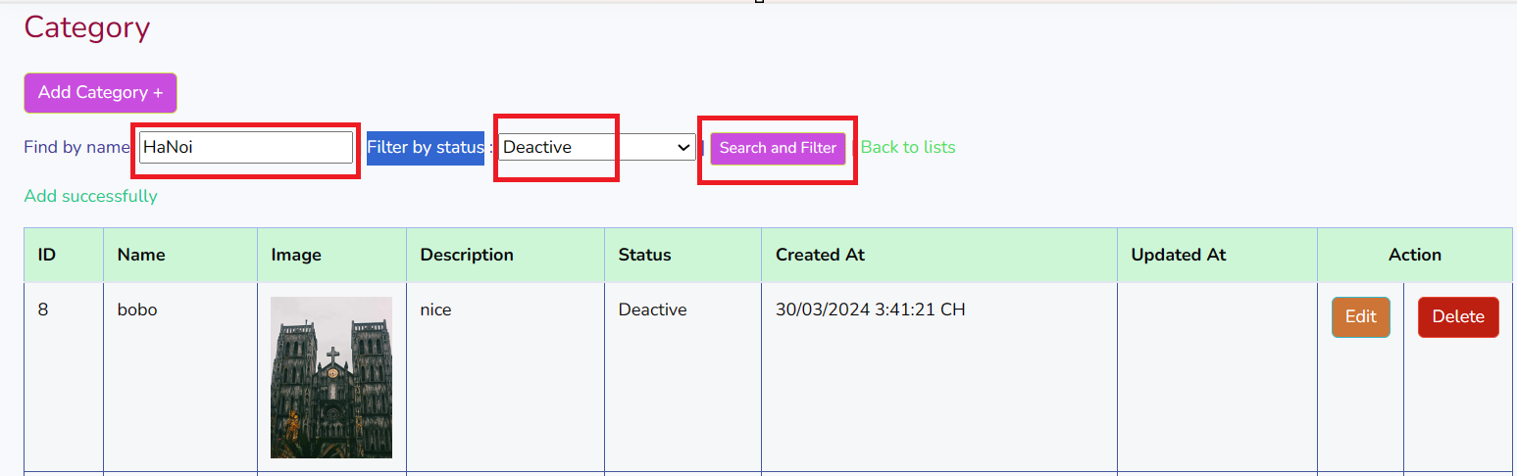

It will display the information you are looking for

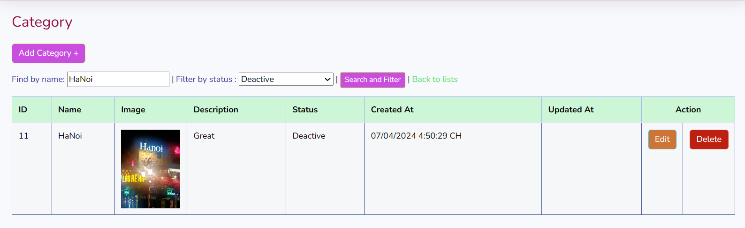

If you want to return to the Category home page, click "Back to list"

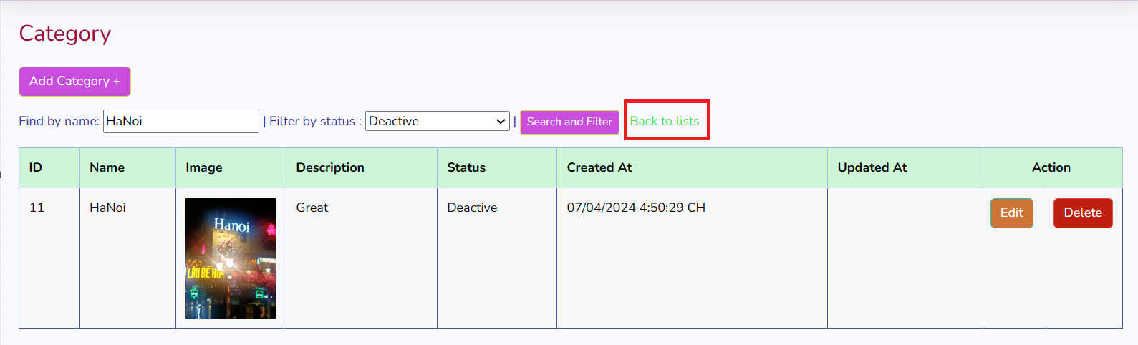

**Course**

When you click on "Course", it will display a course for you to add, edit, delete and display the newly added products.

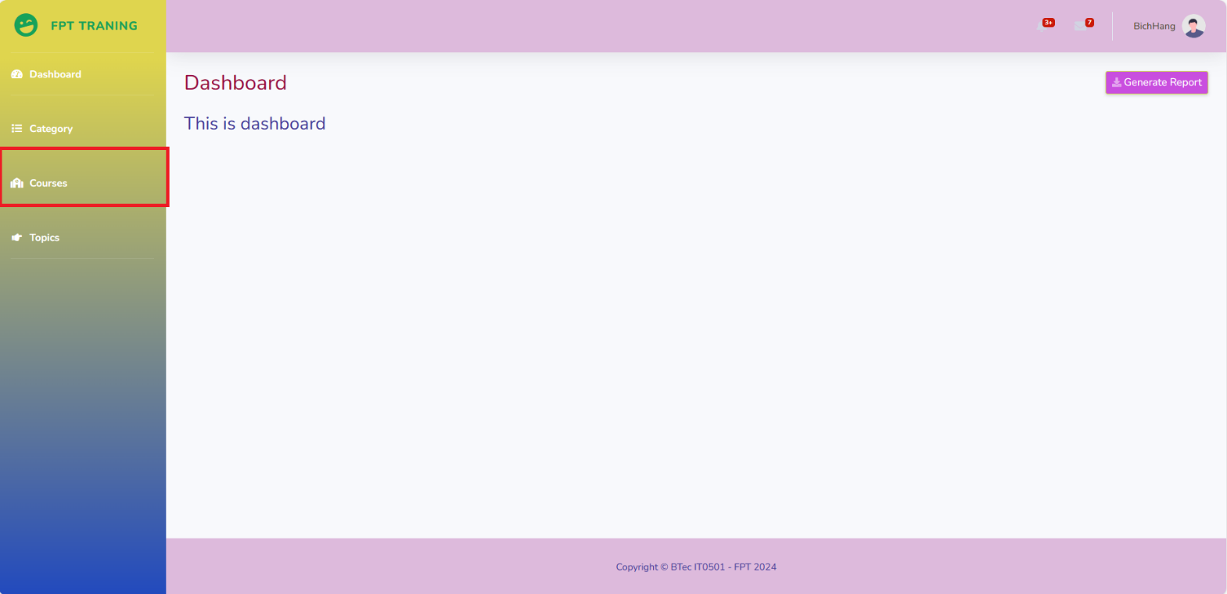

This is the category "Course" displayed

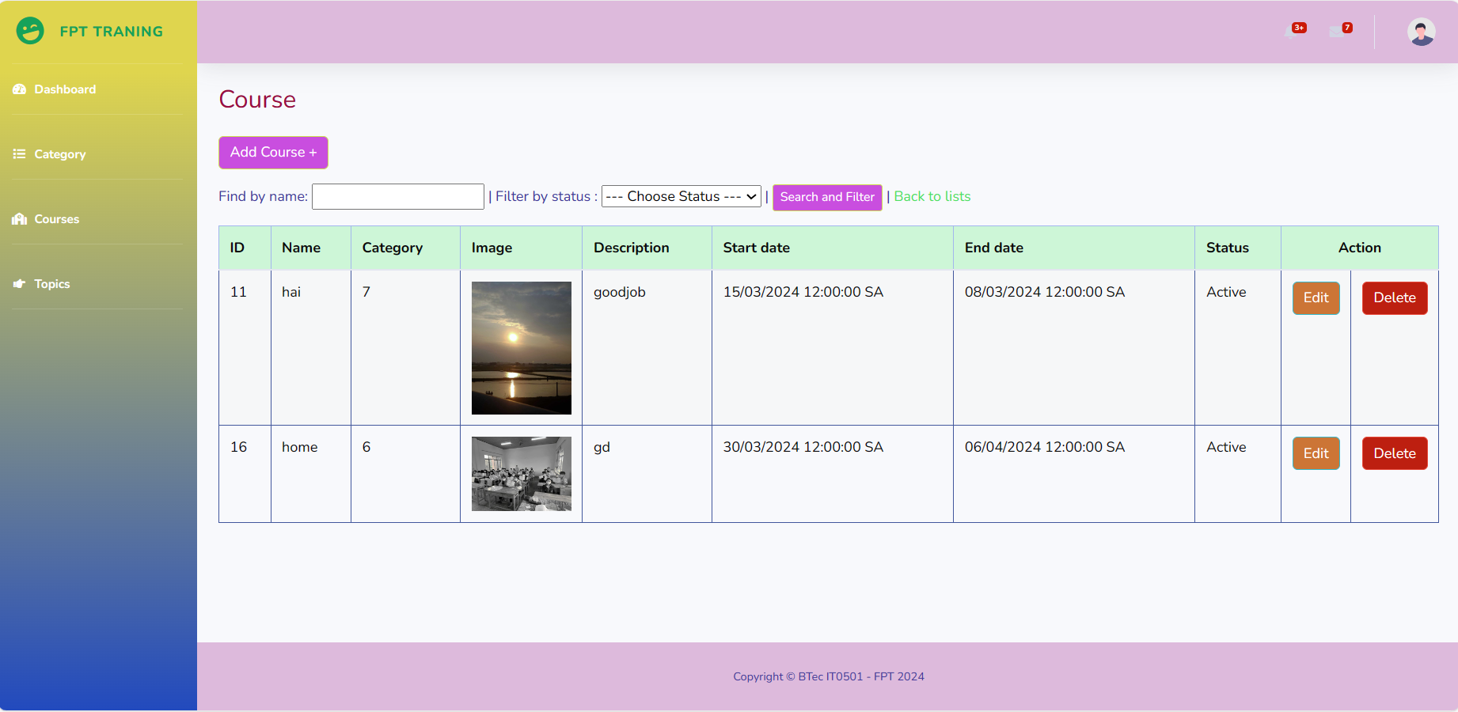

**Add:** Enable the addition of a new course

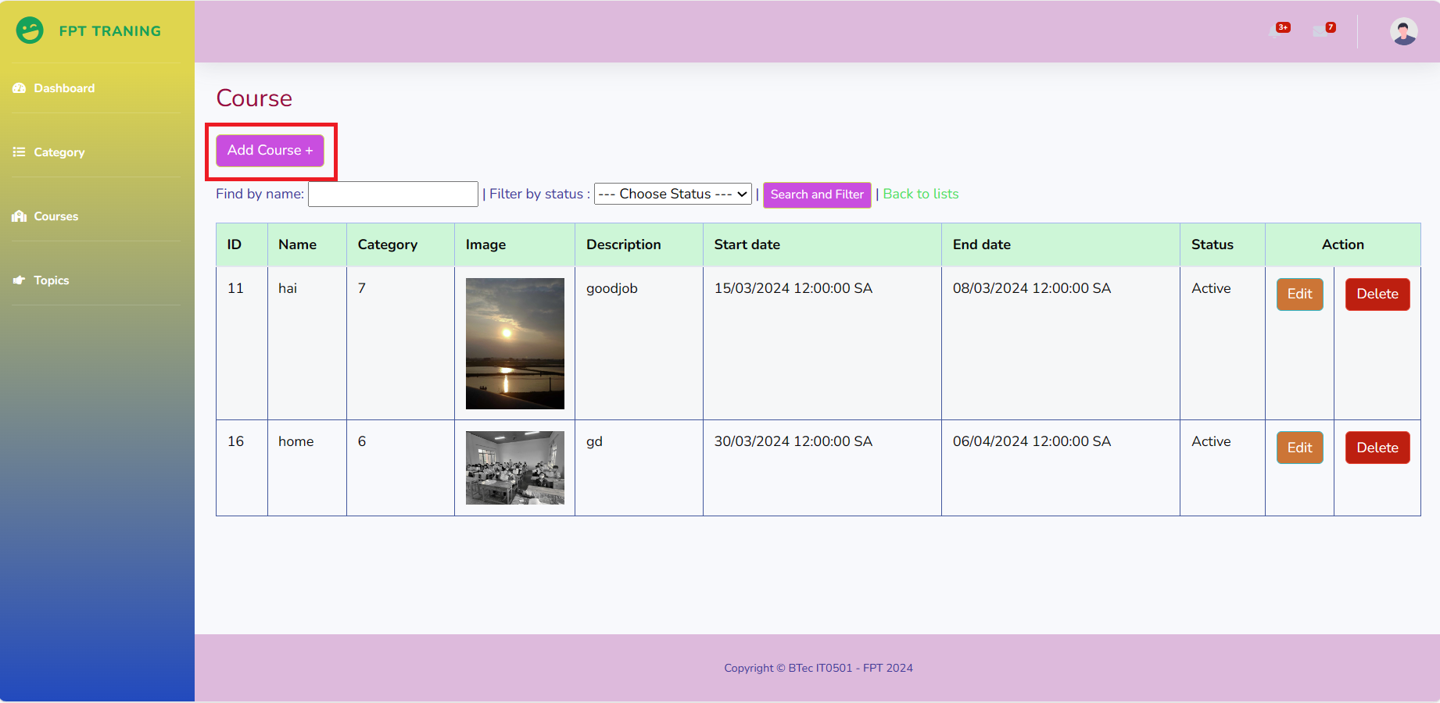

Add the information you need to fill in "Course" and press the "Save" button

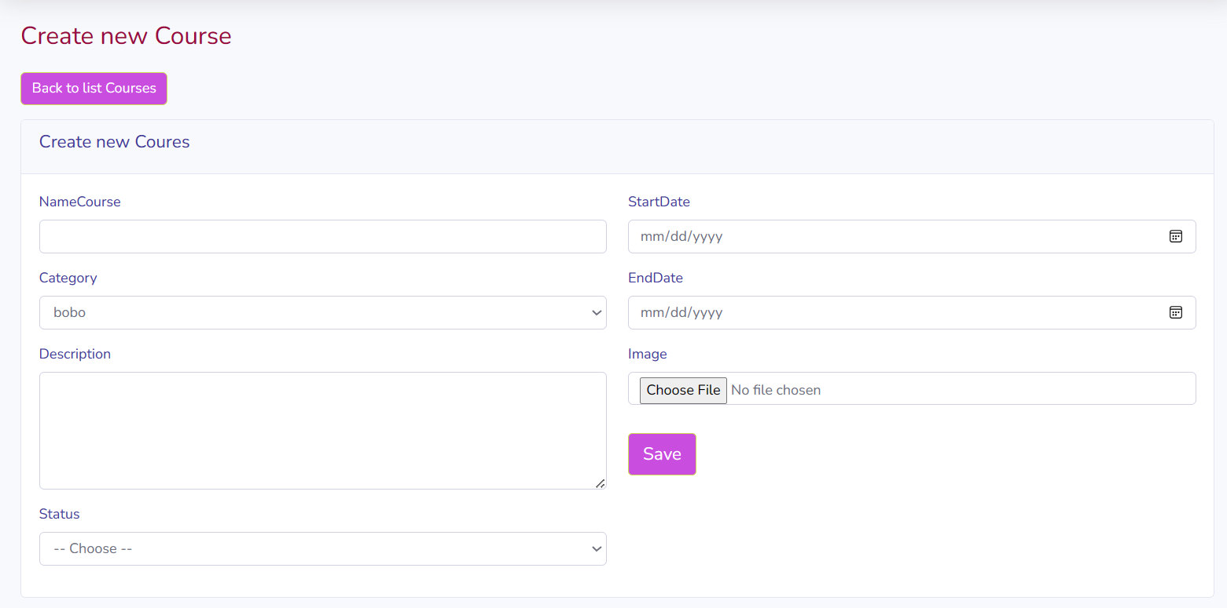

More information press the "Save" button

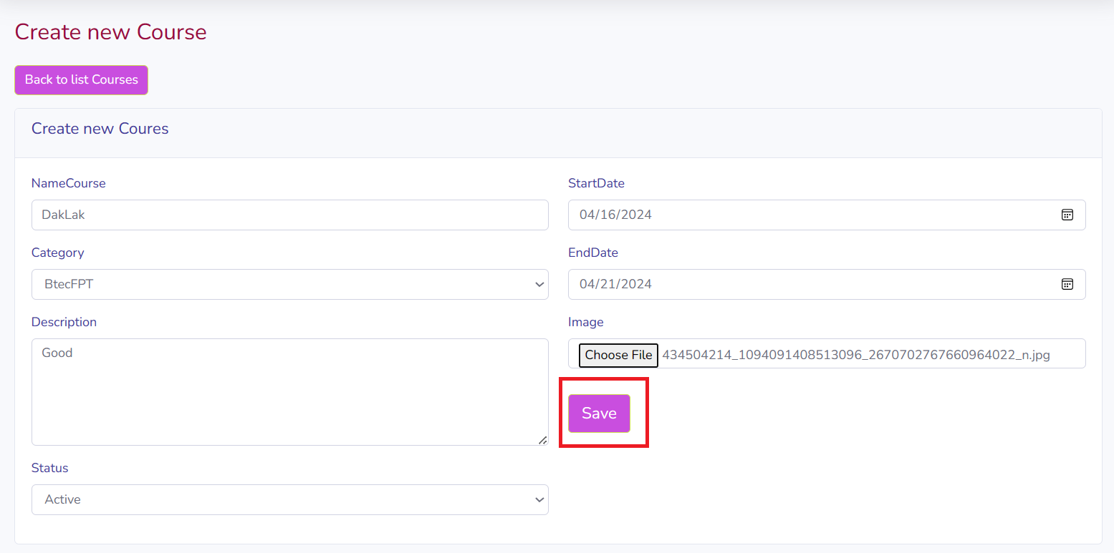

**Add course successful**: Upon clicking " add course" the save operation is successful

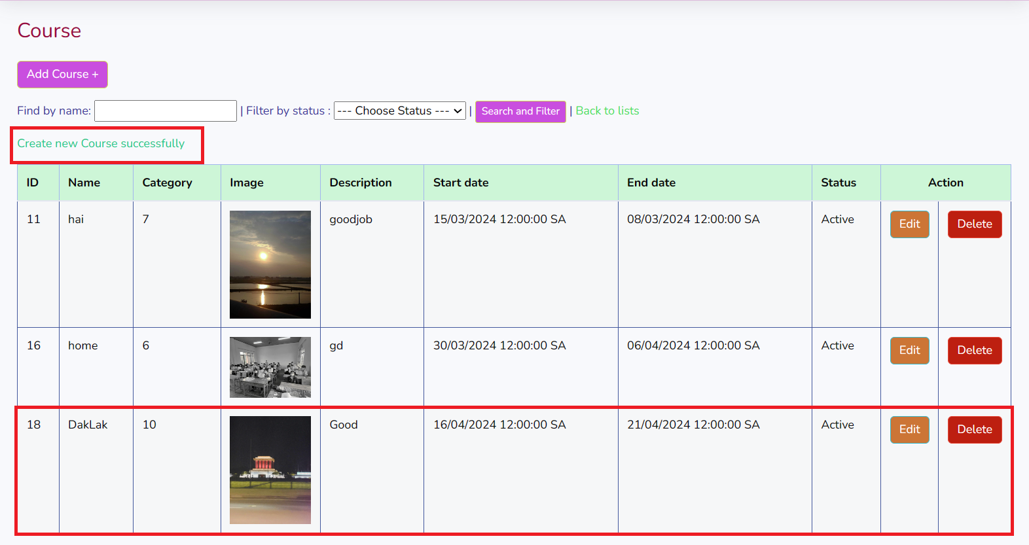

**Edit:** allow modifications to the selected CourseID

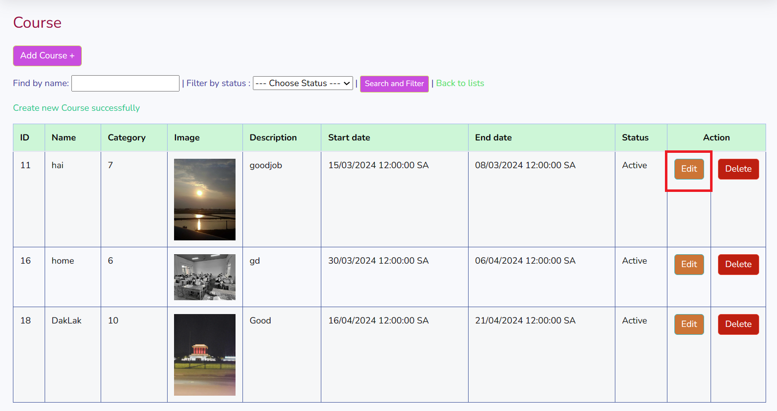

**Edit Course successful**: when clicking the " Update Course" button, the course update is successful

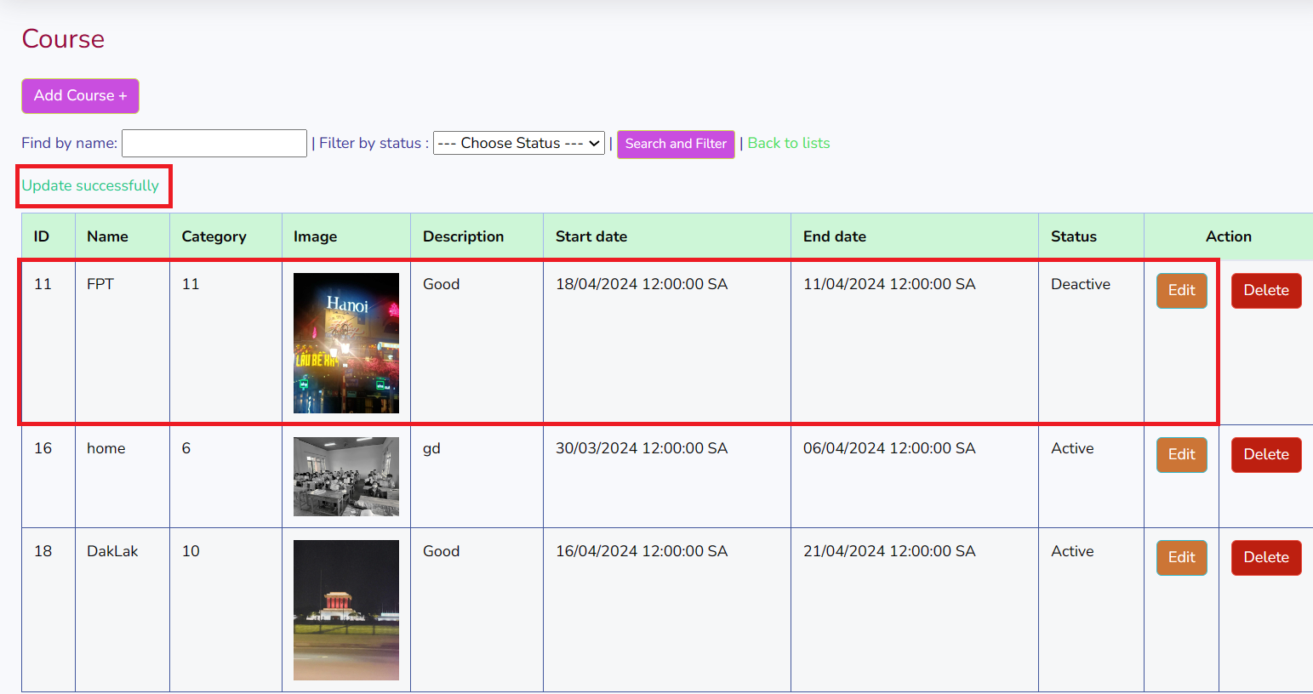

**Delete:** Provide the capability to remove the selected CourseID.

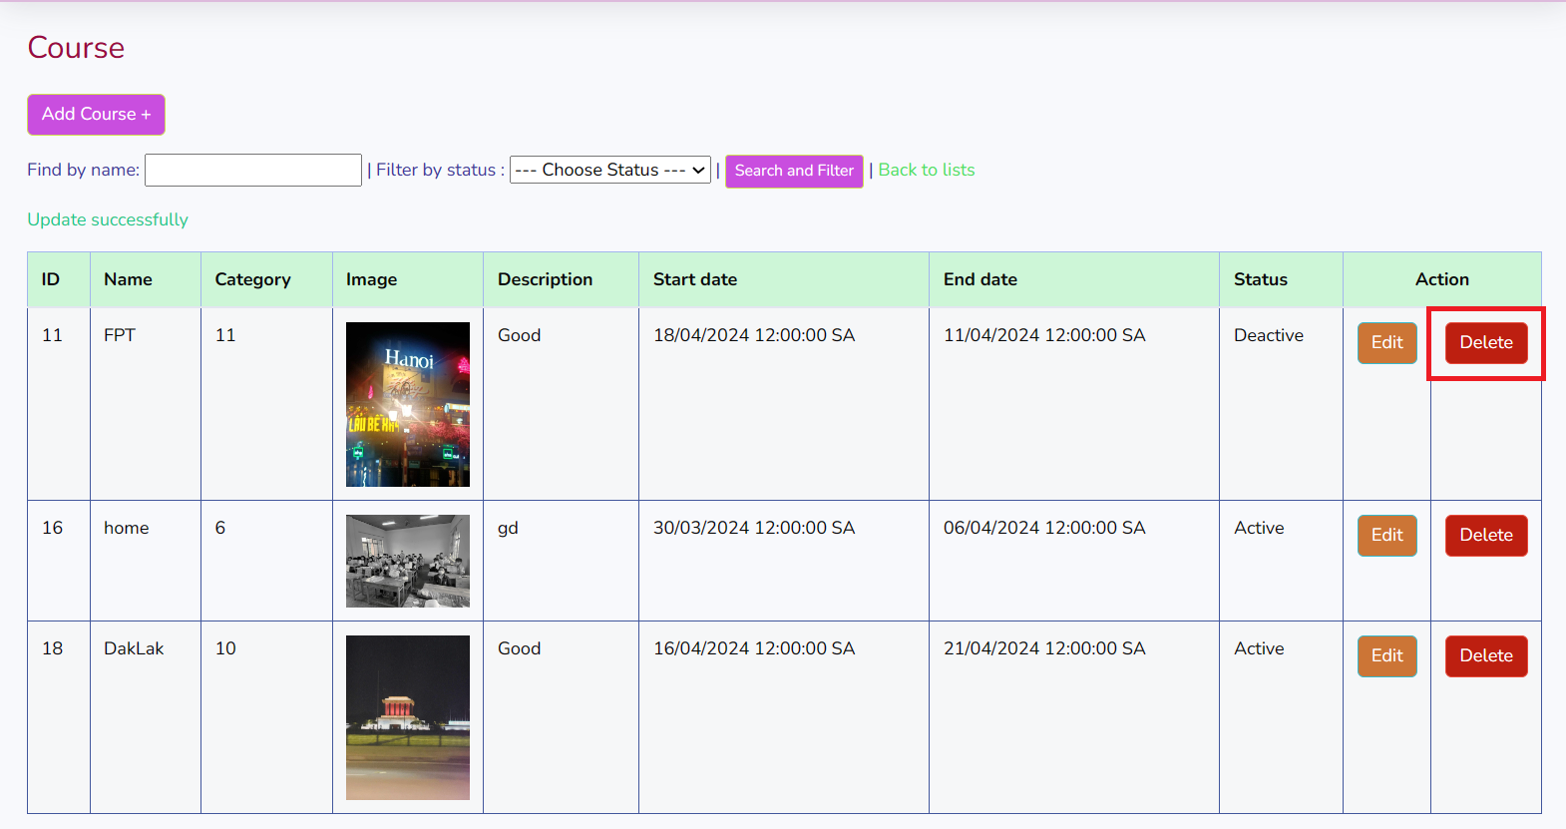

**Delete category successful:** when clicking the" delete category" button, the category deletion is successful.

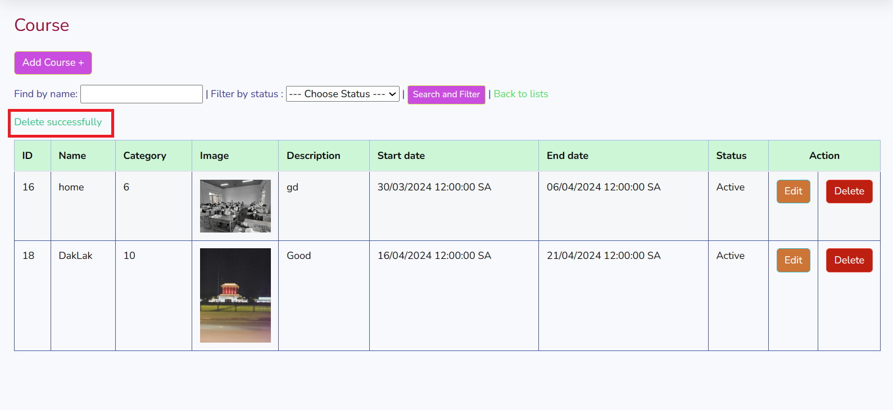

When there are too many courses to search, click "find by name", select "Filter by status" and then press "Search and Filter" to display the content and images of the Course you are searching for.

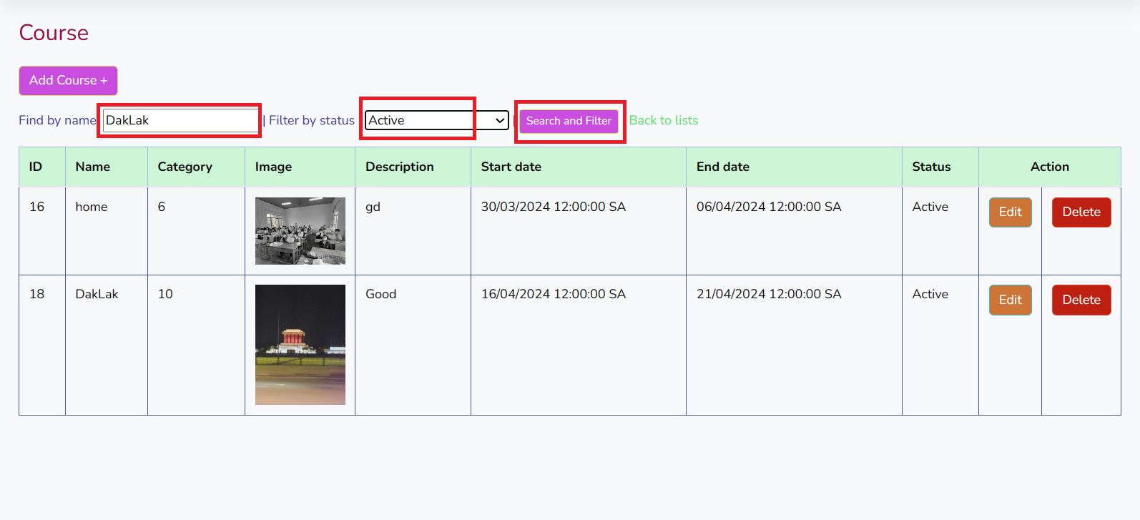

It will display the information you are looking for

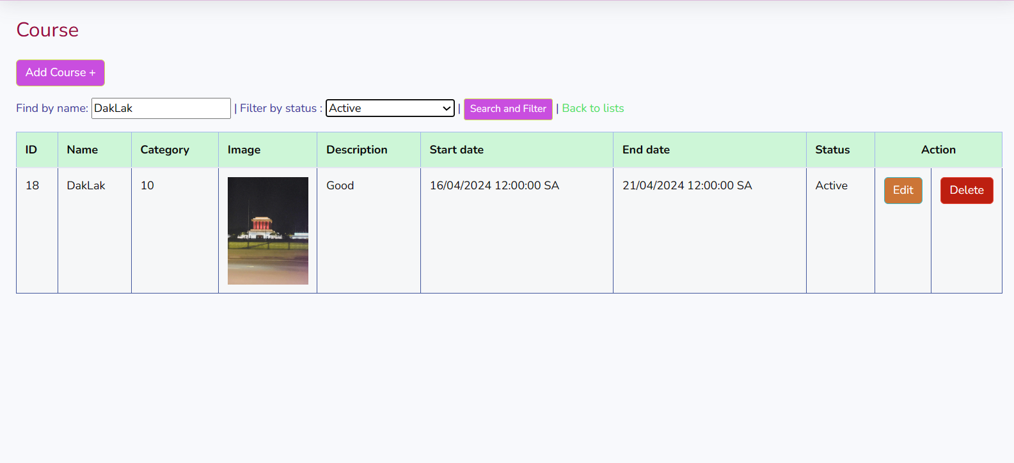

If you want to return to the Course home page, click "Back to list"

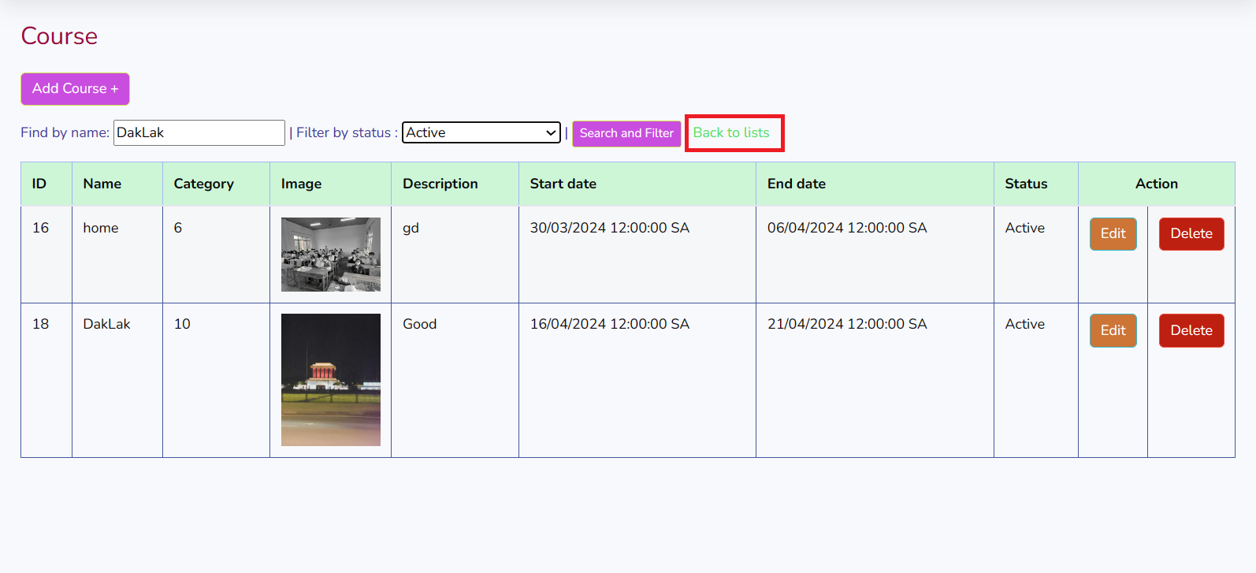

**Topic**

When you click on "Topic", it will display a category for you to add, edit, delete and display the newly added products.

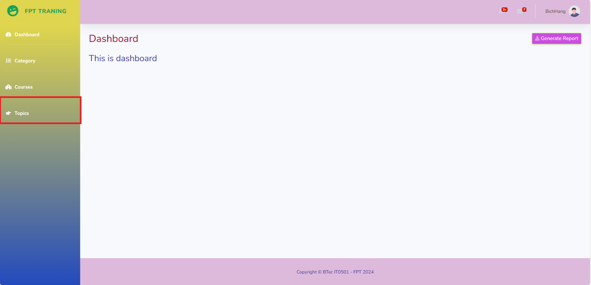

This is the Topic "Topic" displayed

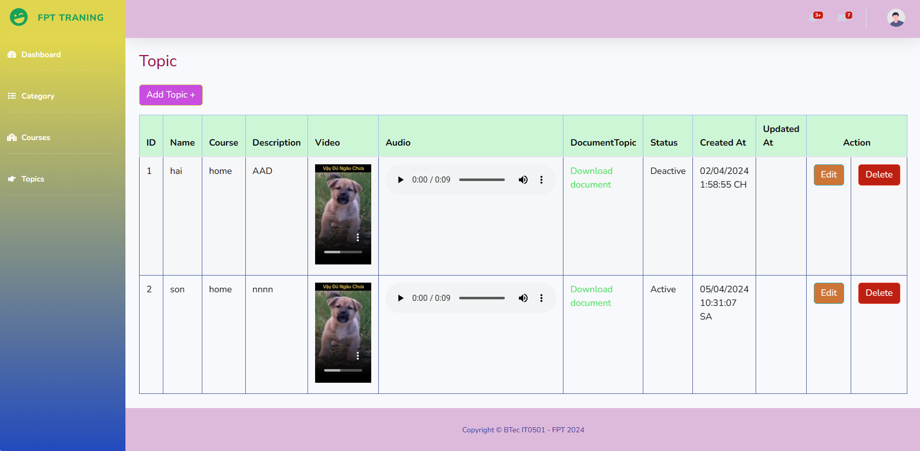

**Add:** Enable the addition of a new course

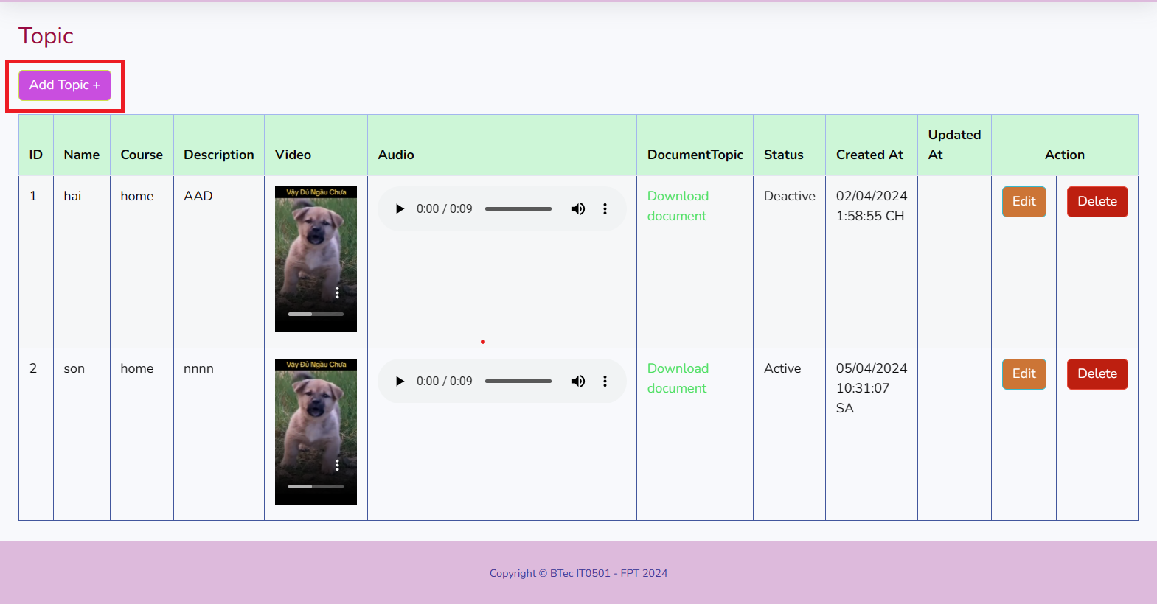

Add the information you need to fill in "Course" and press the "Save" button

## **P6 Review the performance of your business application against the Problem Definition Statement and initial requirements**

1. Functional requirements of system Below are the functional requirements for each actor of the system
   1. Functional requirements of Admin
   2. Functional requirements of Training staff
   3. Functional requirements of Trainer
   4. Functional requirements of Trainee
2. Comparison table
3. Test case

## **M3 Interpret your peer-review feedback and identify opportunities not previously considered**

## **M4 Develop a functional business application based on a specific Software Design Document with supportive evidence of using the preferred tools, techniques and methodologies**

## **M5 Analyse the factors that influence the performance of a business application and use them to undertake a critical review of the design, development and testing stages of your application. Conclude your review by reflectively discussing your previously identified risks**

1. **CONCLUSION**
2. **REFERENCES**